Room 532
SpectraMax ID3 Multimode Plate reader: https://docs.google.com/spreadsheets/d/1KbFVskgC_AGKBf3yReYDG9V7Kkh6yGbLKEpqaTX8NHI/edit?usp=sharing
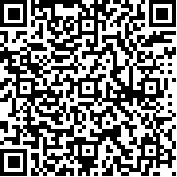

Room 543
Azure C600 Multi Mode gel doc system: https://docs.google.com/spreadsheets/d/1DapRqFKclbgogwbPQ5xrOi2o9KBk3GjhxsYmbj4FQ3A/edit?usp=sharing
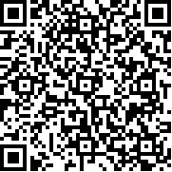

Room 547
X-Ray Film Processor: https://docs.google.com/spreadsheets/d/1QiMTe5eqCiy8jiHEEK11NpoPB1qw9xqq-4fKdWdN0GE/edit?usp=sharing
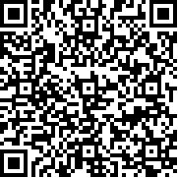

Room 671
Quick Drop: https://docs.google.com/spreadsheets/d/1fgVquJPgHzeDUUMNGbVWapXn30UxCdKRFfcZIs6J8jE/edit?usp=sharing
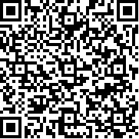

Spectramax Gemini Plate Reader: https://docs.google.com/spreadsheets/d/1dqn-5ZQRJfU8_i9BtcsKJSaFjf0qy4q0kQujI0vRzGk/edit?usp=sharing
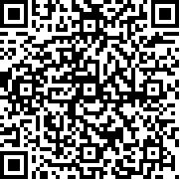

Room 732
Azure C300 Chemi Gel Doc: https://docs.google.com/spreadsheets/d/1kd2RCgihmPd1x3b-2KMVMXMj24AyPp_ve-GZvgaoSPU/edit?usp=sharing
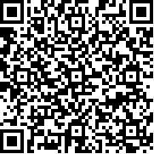

Beckman DU640 Spectrometer: https://docs.google.com/spreadsheets/d/1sDUJYdGz6aGGHlOVdI7l3Z0_6MBgzzDS_YN8m45ZZzM/edit?usp=sharing
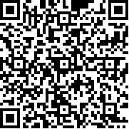

LI COR Odyssey CLx Imaging System:
https://docs.google.com/spreadsheets/d/1prA2l5I2qaW3FlyeHDDeTXFa3U_OTCYTqmkOq-oI3-8/edit#gid=196656535
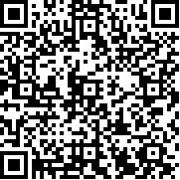

Quick Drop: https://docs.google.com/spreadsheets/d/1tzu4lHdDzX2BYEAZmMz5gKhP-_AGpPKSsTQa4LTFo2M/edit?usp=sharing
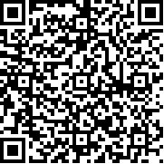

Thermo Varioskan: https://docs.google.com/spreadsheets/d/1hnFf2Fmrbo5PI2TdriQmhfb2UJrKpDwVFOkyotFUcps/edit?usp=sharing
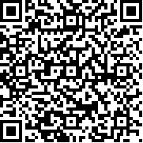

Room 869
Nano Drop 2000: https://docs.google.com/spreadsheets/d/1pE7LAFmTLbvZ10h_3-oJRmg57mmnwBWfzuhWjBAwJ9M/edit?usp=sharing
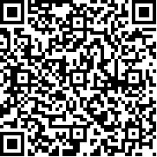

Spectramax ABS plus plate reader: https://docs.google.com/spreadsheets/d/1jlm--1f_XISlSiYe5U5XgKQymKJxzQTPyTJqR_bqaGs/edit?usp=sharing
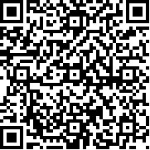

Room 872
Leica Cyrostat
https://docs.google.com/spreadsheets/d/1y_tY7Mg-RqbEhDeGzksmDWOhkgYwMyRDcJmenHOA-BE/edit#gid=196656535
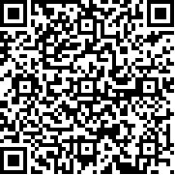

Room B214
Tissue Processor
https://docs.google.com/spreadsheets/d/1cBE_uNzvLNLcgStS2YURiMQyjjTcczfvDnjPU1VjEyg/edit#gid=1005454443
